1.To configure 2 slave machines (agents) in Jenkins Master, follow these steps:

Task: Configure Two Jenkins Slave Machines
Prerequisites
- Jenkins Master Server is installed and running.
- Two Linux machines (Slave1 and Slave2) are available.
- Java is installed on both slave machines.
- SSH connectivity is enabled between Master and Slaves.

Step 1: Install Java on Both Slave Machines
sudo apt update
sudo apt install openjdk-17-jdk -y
java -version

Step 2: Create Jenkins User on Slave Machines
sudo adduser jenkins
sudo usermod -aG sudo jenkins
Switch to the Jenkins user:
su - jenkins

Step 3: Generate SSH Key on Jenkins Master
On Jenkins Master:
ssh-keygen
Press Enter for all prompts.

Step 4: Copy SSH Key to Both Slave Machines
For Slave1:
ssh-copy-id jenkins@<Slave1-IP>
For Slave2:
ssh-copy-id jenkins@<Slave2-IP>
Verify:
ssh jenkins@<Slave1-IP>
ssh jenkins@<Slave2-IP>
You should log in without entering a password.

Step 5: Add Slave1 in Jenkins
- Login to Jenkins.
- Go to:
Manage Jenkins
→ Nodes
→ New Node
- Enter:
Node Name : Slave1
Type : Permanent Agent
- Configure:
Field | Value
Number of Executors | 2
Remote Root Directory | /home/jenkins
Labels | linux-slave1
Usage | Use this node as much as possible
Launch Method | Launch agents via SSH
Host
Credentials | Jenkins SSH Credentials
Click Save.

Step 6: Add Slave2 in Jenkins
Again go to:
Manage Jenkins
→ Nodes
→ New Node
Configure:
Field | Value
Node Name | Slave2
Number of Executors | 2
Remote Root Directory | /home/jenkins
Labels | linux-slave2
Usage | Use this node as much as possible
Launch Method | Launch agents via SSH
Host
Credentials | Jenkins SSH Credentials
Click Save.

Step 7: Verify Agents
Go to:
Manage Jenkins
→ Nodes
You should see:
Master Online
Slave1 Online
Slave2 Online

Testing the Slaves
Create a Pipeline Job:
pipeline {
agent { label 'linux-slave1' }

stages {
stage('Test') {
steps {
sh 'hostname'
sh 'java -version'
}
}
}
}
Similarly, test Slave2:
pipeline {
agent { label 'linux-slave2' }

stages {
stage('Test') {
steps {
sh 'hostname'
}
}
}
}

Expected Outcome
✅ Jenkins Master successfully connected to 2 slave machines.
✅ Jobs can be executed on specific agents using labels.
✅ Distributed builds are now enabled in Jenkins.

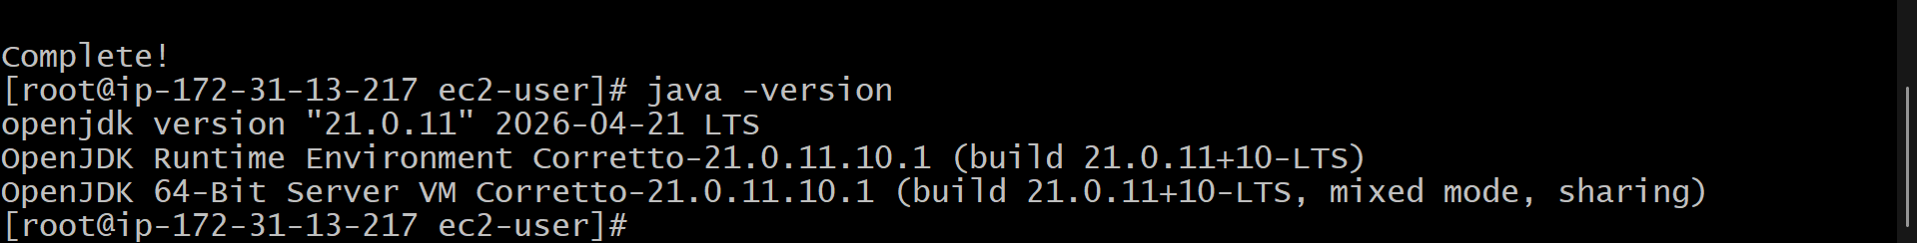
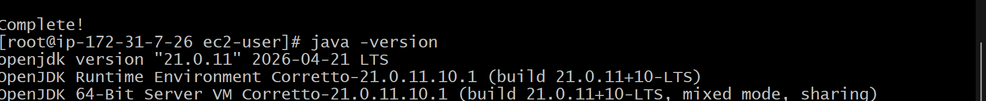
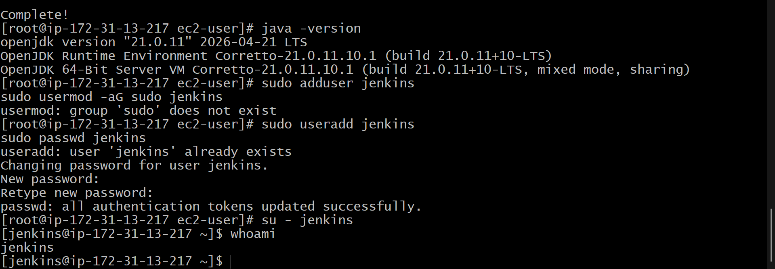
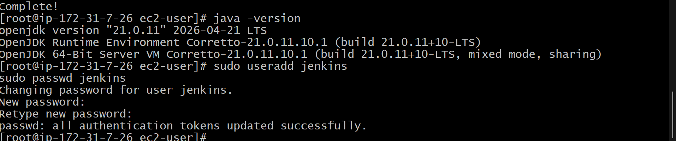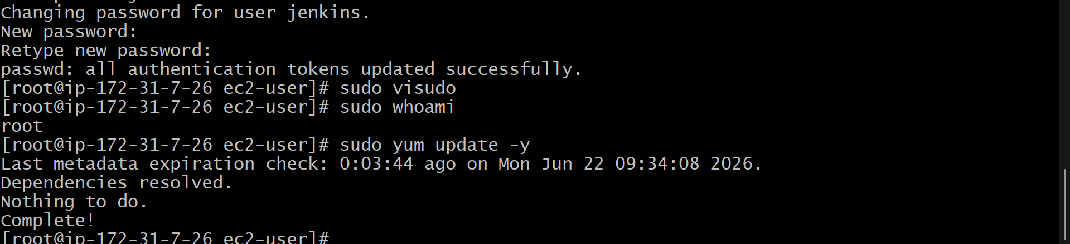
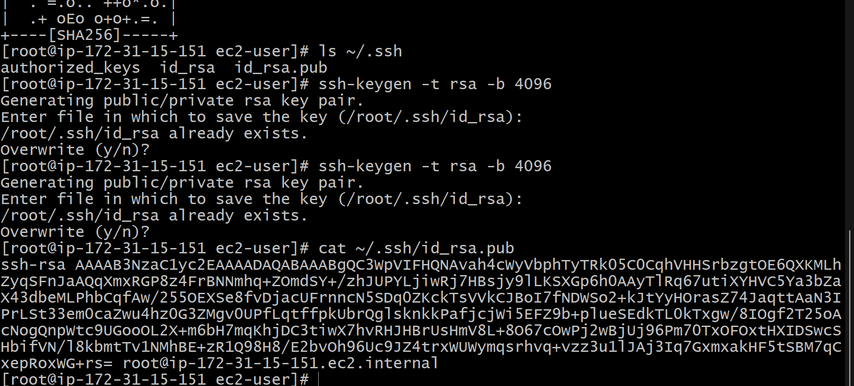

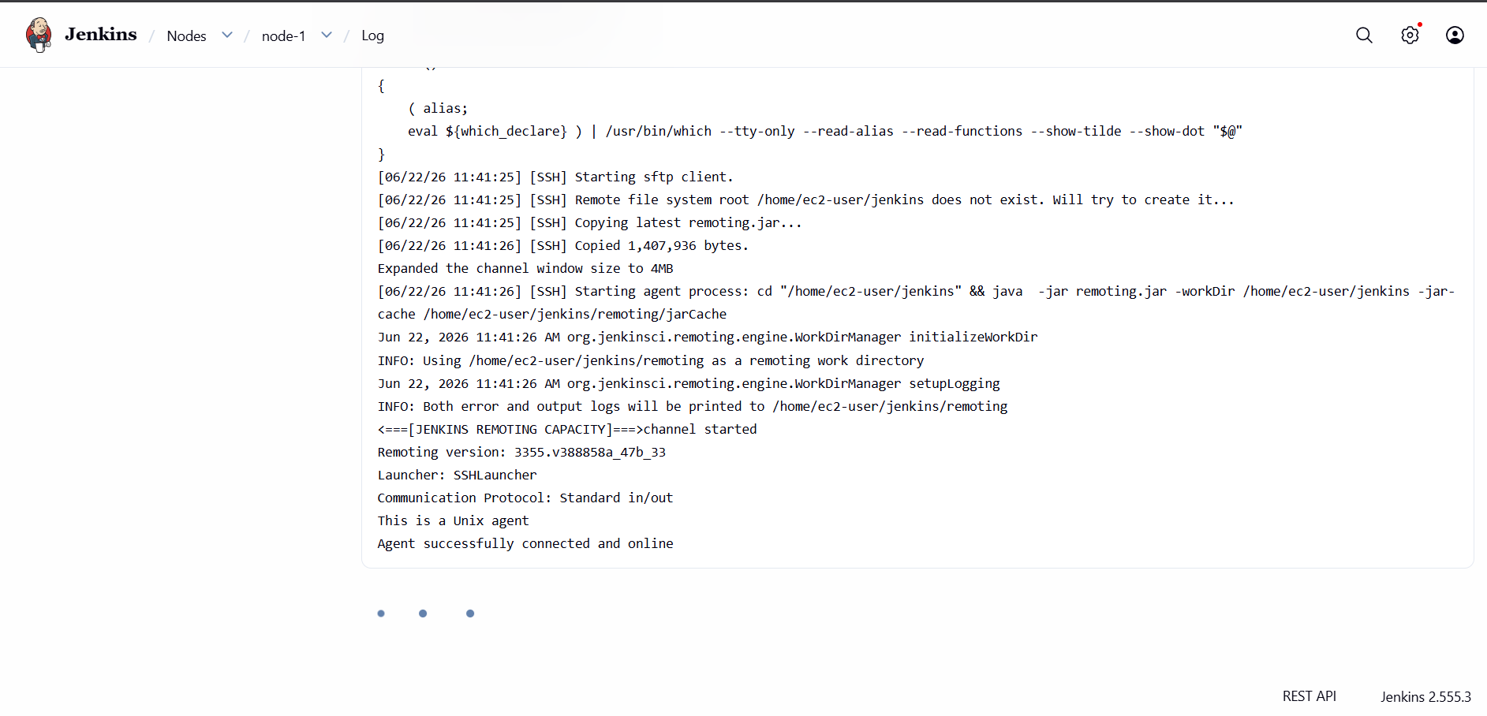

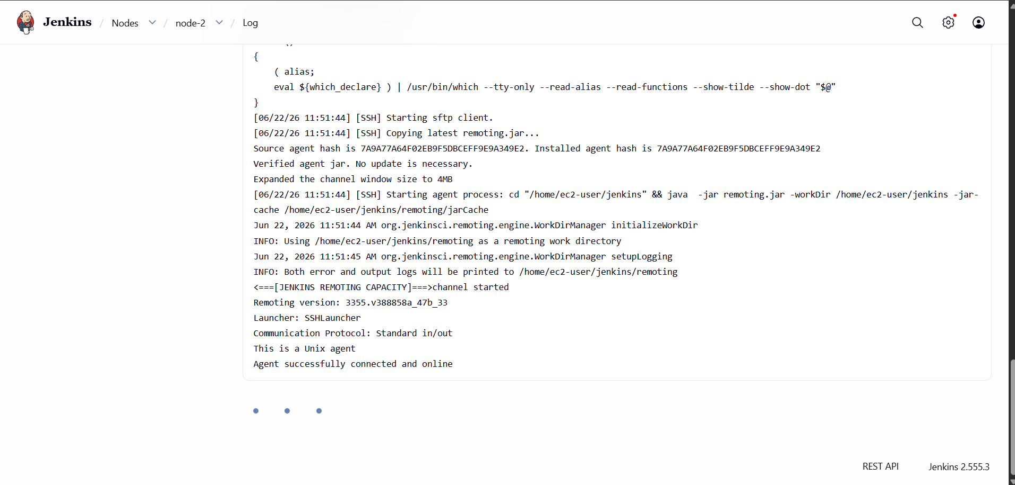
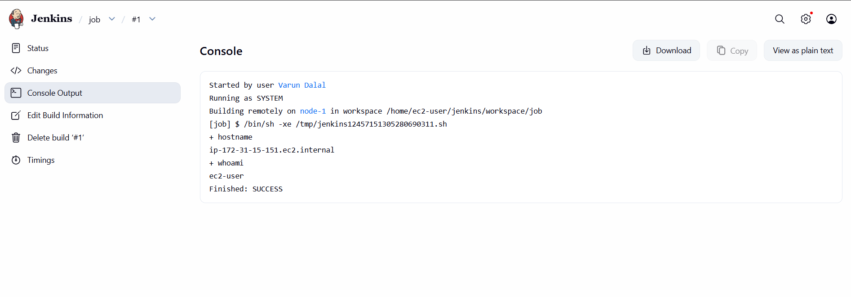
To configure GitHub Webhooks to a Jenkins Job, follow these steps:
Step 1: Install Required Plugin
In Jenkins:
Manage Jenkins
→ Plugins
→ Available Plugins
→ Search "GitHub Integration Plugin"
→ Install
You can also install:
- Git Plugin
- GitHub Plugin

Step 2: Configure the Jenkins Job
- Open your Jenkins Job.
- Click Configure.
- Under Source Code Management, select Git.
Enter your repository URL:
https://github.com/username/repository.git

Step 3: Enable Build Trigger
In the job configuration, go to Build Triggers and select:
GitHub hook trigger for GITScm polling
Save the job.

Step 4: Configure GitHub Webhook
Go to your GitHub repository:
Repository
→ Settings
→ Webhooks
→ Add webhook
Payload URL
If Jenkins is public:
http://<JENKINS_PUBLIC_IP>:8080/github-webhook/
Example:
http://54.210.10.20:8080/github-webhook/
Important: Include the trailing /.

Content Type
application/json

Secret
Leave empty (optional).

Events
Choose:
Just the push event
Click Add webhook.

Step 5: Verify Webhook Delivery
Go to:
GitHub
→ Settings
→ Webhooks
→ Recent Deliveries
You should see:
Response Code: 200

Step 6: Test the Webhook
Make a code change:
git add .
git commit -m "Webhook test"
git push origin main
Jenkins should automatically trigger the build.

If Jenkins is Running on EC2
Make sure the EC2 Security Group allows:
Type | Port
HTTP | 8080
SSH | 22

Common Errors
404 Error
Webhook URL is incorrect.
Correct:
http://<IP>:8080/github-webhook/
Incorrect:
http://<IP>:8080/github-webhook

403 Error
CSRF issue.
Go to:
Manage Jenkins
→ Security
→ CSRF Protection
Ensure the GitHub webhook endpoint is not blocked.

Timeout Error
Your Jenkins server is not publicly accessible.
Verify:
curl http://<JENKINS_PUBLIC_IP>:8080

Architecture Flow
Developer Pushes Code
↓
GitHub Repository
↓
Webhook
↓
Jenkins http://IP:8080/github-webhook/
↓
Jenkins Job Triggered
↓
Build Executes
This completes the configuration of GitHub Webhooks with Jenkins, enabling automatic builds whenever code is pushed to the repository.

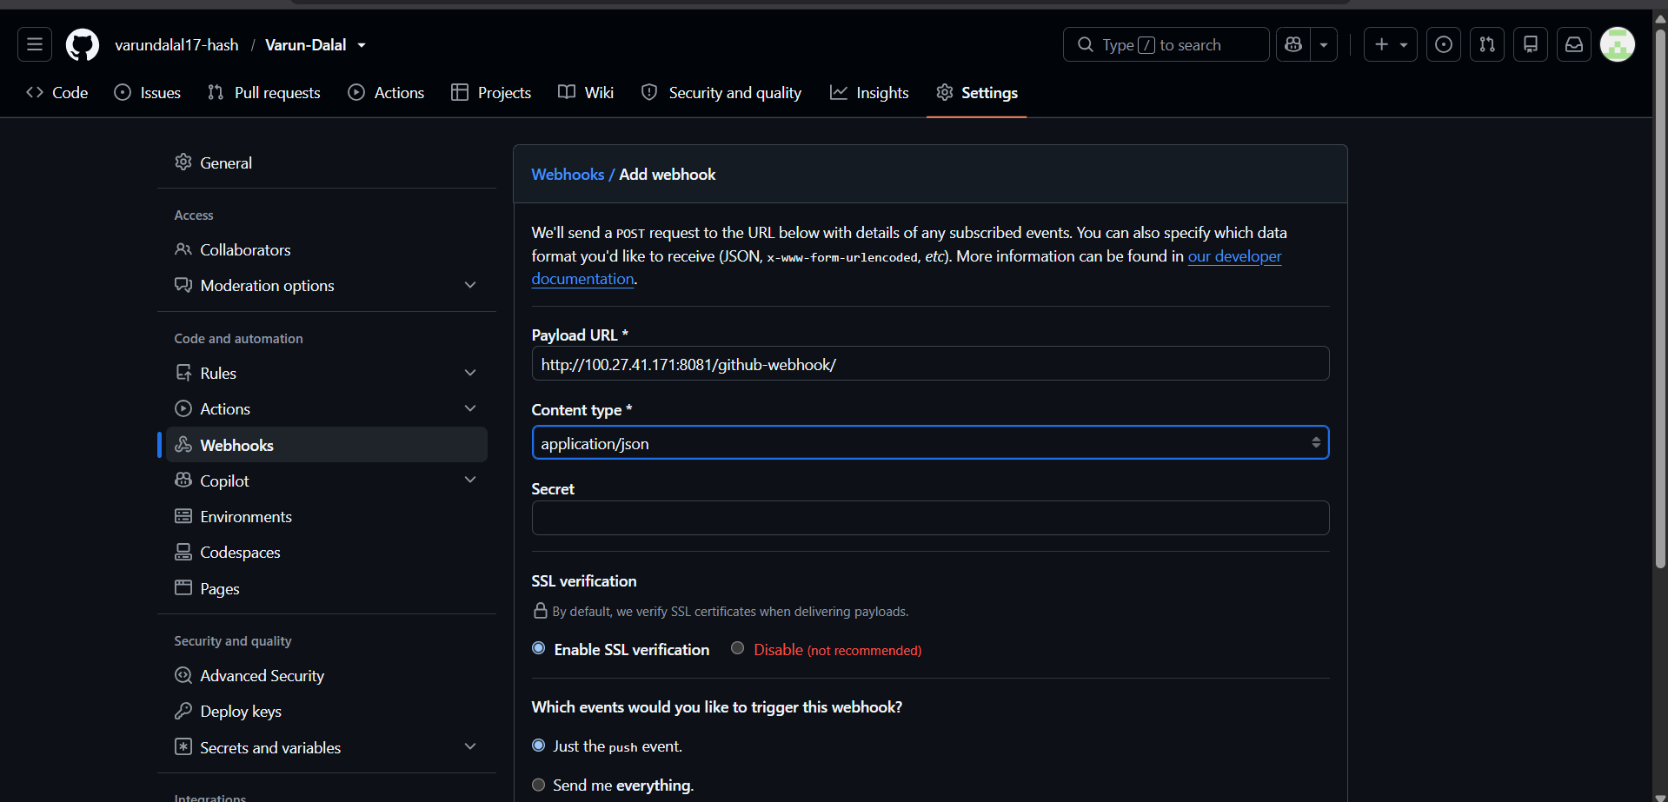

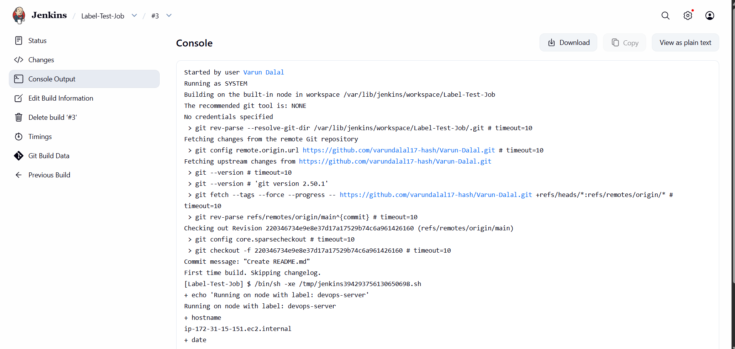

1. Configure Poll SCM
Purpose: Jenkins periodically checks the Git repository for changes. If it detects a new commit, it triggers a build.
Steps:
- Open your Jenkins job.
- Click Configure.
- Go to Build Triggers.
- Select Poll SCM.
- Enter the schedule.
Examples:
Schedule | Meaning
* * * * * | Check every minute
H/5 * * * * | Check every 5 minutes
H/10 * * * * | Check every 10 minutes
H * * * * | Check every hour
Example:
H/5 * * * *
Jenkins checks the repository every 5 minutes and starts a build only if there are code changes.

2. Configure Build Periodically
Purpose: Jenkins triggers the build at a fixed schedule regardless of whether code has changed.
Steps:
- Open your Jenkins job.
- Click Configure.
- Go to Build Triggers.
- Select Build periodically.
- Enter the schedule.
Examples:
Schedule | Meaning
* * * * * | Build every minute
H/5 * * * * | Build every 5 minutes
0 * * * * | Build every hour
0 9 * * * | Build every day at 9:00 AM
0 0 * * 0 | Build every Sunday at midnight
Example:
H/5 * * * *
Jenkins will run the build every 5 minutes, even if there are no code changes.

Difference Between Poll SCM and Build Periodically
Feature | Poll SCM | Build Periodically
Checks Git for changes | ✅ Yes | ❌ No
Builds only on code changes | ✅ Yes | ❌ No
Runs on a fixed schedule | ❌ No | ✅ Yes
Suitable for CI/CD | ✅ Yes | ❌ Usually used for scheduled jobs

Example Configuration
Poll SCM
H/5 * * * *
Checks Git every 5 minutes and builds only if changes exist.
Build Periodically
0 9 * * *
Runs the build every day at 9:00 AM.

Cron Format Used by Jenkins
MINUTE HOUR DAY_OF_MONTH MONTH DAY_OF_WEEK
Example:
30 14 * * 1-5
Meaning: Run at 2:30 PM, Monday to Friday.

Workflow
Poll SCM:
Git Repository → Jenkins checks → New Commit Found → Build Starts

Build Periodically:
Scheduled Time Reached → Build Starts

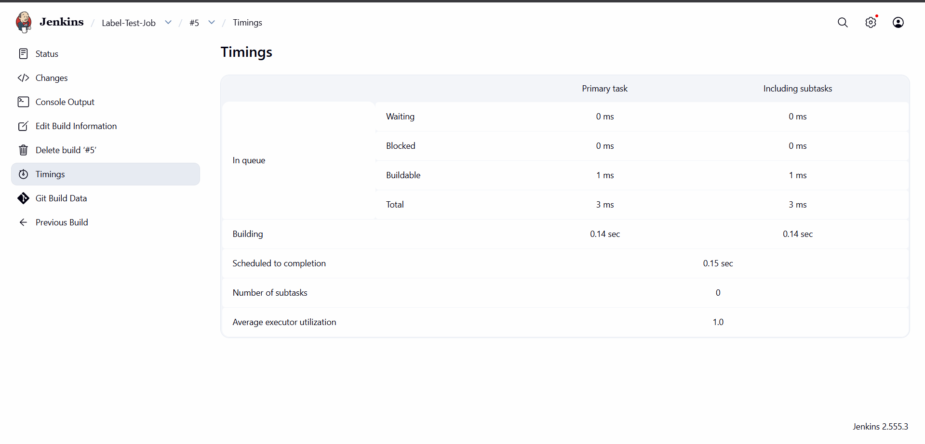

4.Jenkins Server Backup Using a Bash Script
Objective
To take a complete backup of the Jenkins server, including jobs, plugins, users, credentials, and configuration files, using a Bash script.

Prerequisites
- Jenkins server is installed and running.
- User has sudo privileges.
- Access to the Jenkins server through SSH.

Step 1: Login to the Jenkins Server
ssh -i <key-file>.pem ec2-user@<server-ip>

Step 2: Verify the Jenkins Home Directory
Check the contents of the Jenkins directory:
sudo ls -l /var/lib/jenkins
Sample output:
config.xml
credentials.xml
jobs/
plugins/
secrets/
users/
workspace/
This confirms that the Jenkins Home directory is:
/var/lib/jenkins

Step 3: Create a Backup Directory
Create a directory to store Jenkins backups.
sudo mkdir -p /backup/jenkins
Verify:
ls -ld /backup/jenkins

Step 4: Create the Backup Script
Create a shell script:
sudo vi /usr/local/bin/jenkins_backup.sh
Add the following script:
#!/bin/bash

JENKINS_HOME="/var/lib/jenkins"
BACKUP_DIR="/backup/jenkins"
DATE=$(date +%F-%H-%M-%S)

mkdir -p $BACKUP_DIR

echo "Stopping Jenkins..."
systemctl stop jenkins

echo "Taking Backup..."
tar -czvf $BACKUP_DIR/jenkins_backup_$DATE.tar.gz $JENKINS_HOME

echo "Starting Jenkins..."
systemctl start jenkins

echo "Backup completed successfully."
echo "Backup File: $BACKUP_DIR/jenkins_backup_$DATE.tar.gz"
Save and exit:
:wq

Step 5: Give Execute Permission
sudo chmod +x /usr/local/bin/jenkins_backup.sh

Step 6: Execute the Backup Script
sudo /usr/local/bin/jenkins_backup.sh
Sample output:
Stopping Jenkins...
Taking Backup...
Starting Jenkins...
Backup completed successfully.
Backup File:
/backup/jenkins/jenkins_backup_2026-06-23-06-14-50.tar.gz

Step 7: Verify the Backup File
ls -lh /backup/jenkins/
Sample output:
-rw-r--r-- 1 root root 45M Jun 23 06:14 jenkins_backup_2026-06-23-06-14-50.tar.gz

Step 8: Verify the Backup Contents
tar -tzf /backup/jenkins/jenkins_backup_2026-06-23-06-14-50.tar.gz | head -20

Step 9: Configure Automatic Daily Backups
Open the crontab:
sudo crontab -e
Add the following entry to take a backup every day at 2:00 AM:
0 2 * * * /usr/local/bin/jenkins_backup.sh
Verify:
sudo crontab -l

Restore Procedure
Step 1: Stop Jenkins
sudo systemctl stop jenkins
Step 2: Extract the Backup
sudo tar -xzvf /backup/jenkins/jenkins_backup_2026-06-23-06-14-50.tar.gz -C /
Step 3: Start Jenkins
sudo systemctl start jenkins

Files and Directories Included in the Backup
The backup contains:
- Jenkins jobs
- Plugins
- User accounts
- Credentials and secrets
- Build history
- Node configurations
- Global Jenkins configuration
- Workspace and system settings

Conclusion
The Jenkins server backup was successfully created using a Bash script and stored in:
/backup/jenkins/
This backup can be restored whenever required to recover the Jenkins environment and configurations.

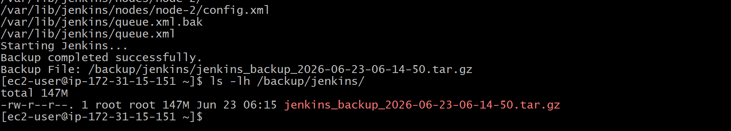

5.Jenkins Backup Using ThinBackup Plugin
Objective
To take a backup of the Jenkins server using the ThinBackup plugin.

Step 1: Login to Jenkins
Open Jenkins in your browser:
http://<JENKINS_SERVER_IP>:8080
Login using your Jenkins credentials.

Step 2: Install ThinBackup Plugin
- Navigate to Manage Jenkins.
- Click Plugins.
- Select the Available Plugins tab.
- Search for ThinBackup.
- Select the plugin and click Install without restart.
- Wait for the installation to complete.

Step 3: Create a Backup Directory on the Server
SSH into the Jenkins server and execute:
sudo mkdir -p /backup/jenkins-thinbackup
sudo chown -R jenkins:jenkins /backup/jenkins-thinbackup
sudo chmod -R 755 /backup/jenkins-thinbackup
Verify:
ls -ld /backup/jenkins-thinbackup

Step 4: Configure ThinBackup
- Go to Manage Jenkins → ThinBackup.
- In the Backup Directory field, enter:
/backup/jenkins-thinbackup
- Enable the following options:
  - Backup additional files
  - Backup plugin archives
  - Backup next build numbers
  - Backup build results (optional)
- Click Save.

Step 5: Take a Manual Backup
- Navigate to:
Manage Jenkins → ThinBackup
- Click:
Backup Now
Wait until the backup process completes.

Step 6: Verify the Backup
Check the backup directory:
ls -l /backup/jenkins-thinbackup
Example output:
FULL-2026-06-23_06-29
Check the contents:
find /backup/jenkins-thinbackup
Example:
/backup/jenkins-thinbackup/FULL-2026-06-23_06-29/users
/backup/jenkins-thinbackup/FULL-2026-06-23_06-29/nodes
/backup/jenkins-thinbackup/FULL-2026-06-23_06-29/installedPlugins.xml
/backup/jenkins-thinbackup/FULL-2026-06-23_06-29/backup-completed.info

Step 7: Configure Automatic Backup (Optional)
Go to:
Manage Jenkins → ThinBackup
Set:
Full Backup Schedule: 0 2 * * *
Differential Backup Schedule: 0 */6 * * *
This configuration creates:
- A full backup every day at 2:00 AM.
- A differential backup every 6 hours.
Click Save.

Restore Procedure
- Stop Jenkins:
sudo systemctl stop jenkins
- Go to:
Manage Jenkins → ThinBackup → Restore
- Select the required backup folder:
FULL-2026-06-23_06-29
- Click Restore.
- Start Jenkins:
sudo systemctl start jenkins

Conclusion
Successfully installed and configured the ThinBackup plugin and created a full backup of the Jenkins server.
Backup Location:
/backup/jenkins-thinbackup/FULL-2026-06-23_06-29
The backup contains Jenkins jobs, plugins, users, credentials, nodes, and configuration files, which can be restored whenever required.

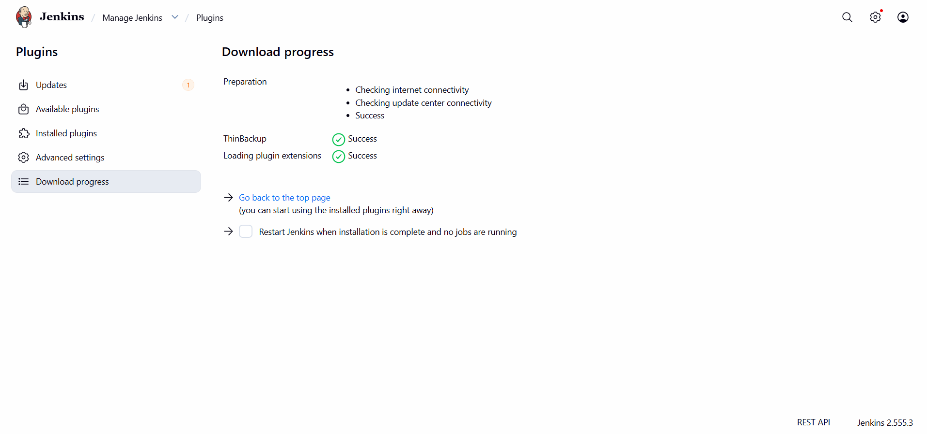

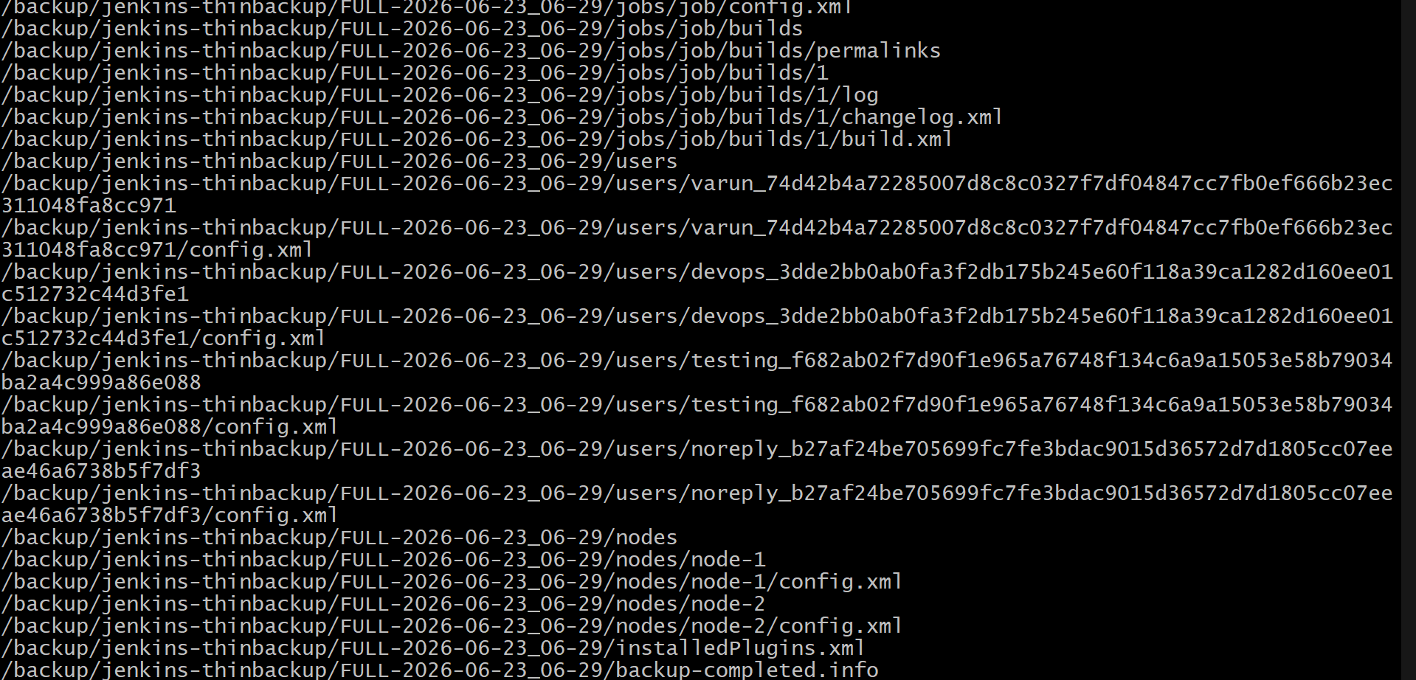

Task 5: Set Up a New Jenkins Server and Restore the Backup Taken in Task 4
Objective
To set up a new Jenkins server and restore the backup created using the ThinBackup plugin from the old Jenkins server.

Step 1: Launch a New EC2 Instance
- Login to AWS Management Console.
- Navigate to EC2 → Launch Instance.
- Configure the instance:
  - AMI: Amazon Linux 2023
  - Instance Type: t2.micro
  - Security Group:
    - SSH (22)
    - Custom TCP (8080)
- Launch the instance and connect to it:
ssh -i test.pem ec2-user@<NEW_SERVER_PUBLIC_IP>

Step 2: Install Java
Check whether Java is installed:
java -version
If Java is not installed:
sudo dnf install java-17-amazon-corretto -y
Verify:
java -version

Step 3: Install Jenkins
Add the Jenkins repository:
sudo wget -O /etc/yum.repos.d/jenkins.repo \
https://pkg.jenkins.io/redhat-stable/jenkins.repo
Import the Jenkins GPG key:
sudo rpm --import https://pkg.jenkins.io/redhat-stable/jenkins.io-2023.key
Install Jenkins:
sudo dnf install jenkins -y
Enable and start Jenkins:
sudo systemctl enable jenkins
sudo systemctl start jenkins
Check the status:
sudo systemctl status jenkins

Step 4: Access Jenkins
Open the browser and access:
http://<NEW_SERVER_PUBLIC_IP>:8080
Get the initial admin password:
sudo cat /var/lib/jenkins/secrets/initialAdminPassword
Complete the Jenkins setup wizard and install the suggested plugins.

Step 5: Install the ThinBackup Plugin
- Go to:
Manage Jenkins → Plugins
- Search for:
ThinBackup
- Click:
Install without restart.

Step 6: Copy the Backup from the Old Server
Download the backup from the old server to the local machine:
scp -i test.pem -r \
ec2-user@44.213.149.235:/backup/jenkins-thinbackup/FULL-2026-06-23_06-29 .
Upload the backup to the new server:
scp -i test.pem -r \
FULL-2026-06-23_06-29 \
ec2-user@44.205.8.0:/tmp/

Step 7: Move the Backup to the ThinBackup Directory
Login to the new server:
ssh -i test.pem ec2-user@44.205.8.0
Create the backup directory:
sudo mkdir -p /backup/jenkins-thinbackup
Move the backup:
sudo mv /tmp/FULL-2026-06-23_06-29 /backup/jenkins-thinbackup/
sudo chown -R jenkins:jenkins /backup/jenkins-thinbackup
sudo chmod -R 755 /backup/jenkins-thinbackup
Verify:
ls -l /backup/jenkins-thinbackup
Expected Output:
FULL-2026-06-23_06-29

Step 8: Configure ThinBackup
Go to:
Manage Jenkins → ThinBackup
Set:
Backup Directory:
/backup/jenkins-thinbackup
Click Save.

Step 9: Restore the Backup
Navigate to:
Manage Jenkins → ThinBackup → Restore
Select:
FULL-2026-06-23_06-29
Click:
Restore
Wait until the restore process completes.

Step 10: Restart Jenkins
sudo systemctl restart jenkins
sudo systemctl status jenkins

Step 11: Verification
Login to Jenkins and verify that the following have been restored successfully:
- Jenkins Jobs
- Users
- Credentials
- Installed Plugins
- Nodes/Agents
- System Configuration
- Build History

Conclusion
A new Jenkins server was successfully created and the backup taken using the ThinBackup plugin was restored successfully. The new Jenkins server now contains all configurations, jobs, plugins, credentials, and user data from the old Jenkins server.

